Activity No. 4.2
Seatwork 4.2: Pointers
Course Code: CPE007 | Program: Computer Engineering
Course Title: Programming Logic and Design | Date Performed: 9 – 18 – 25
Section: CPE11S1 | Date Submitted: 9 – 18 – 25
Name(s): Paula Esguerra | Instructor: Engr. Jimlord Quejado
6. Output
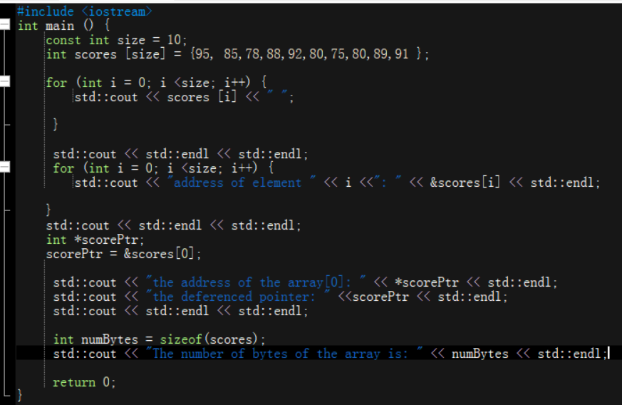
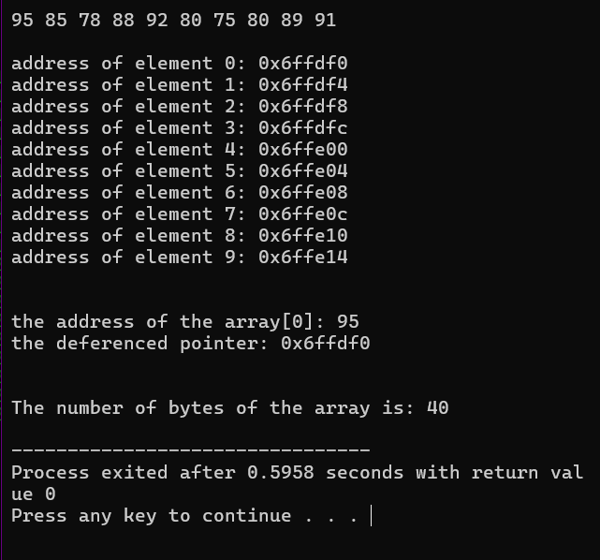
7. Supplementary Activity
I understood, during the discussion how to use Pointers, pointer variable can store the address of an integer. Uses the sizeof operator to calculate the total size the scores array in bytes and stores it in numBytes. Declare constant integer size and initializes to 10. Print the value at the address pointed to by scorePtr. Print the memory address stores in scorePtr.
8. Conclusion
I am learning how to use pointer variable, grasping how to use it, and knowing where it will be used. I am still grasping the for loop is used. Then, I am now acquired how to print a document and absorbed how it will spaced. I will continue to learn C++, in the modules and master my basics.
9. Assessment Rubric

